Create a simple cloud software application for a Hospital Management System using any Cloud Service Provider to demonstrate Software as a Service (SaaS).
Aim
To design, develop, and deploy a simple cloud-based Hospital Management System using Zoho Creator in order to demonstrate Software as a Service (SaaS).

Procedure
- A Zoho Creator account was created and a new application for the Hospital Management System was developed.
- Forms were designed to collect patient details such as name, age, gender, contact number, and medical information.
- Doctor and department details were added to manage hospital staff information.
- Appointment booking forms were created to allow patients to schedule consultations with doctors.
- Workflows and validations were configured to manage patient records and appointment status.
- Reports were generated to view patient lists, doctor schedules, and appointment details.
- The application was deployed on the Zoho Creator cloud platform and shared via a web URL for user access
Output
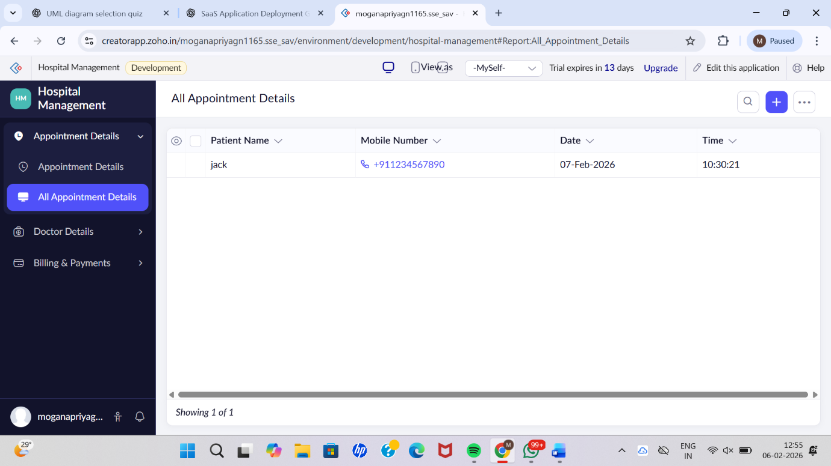

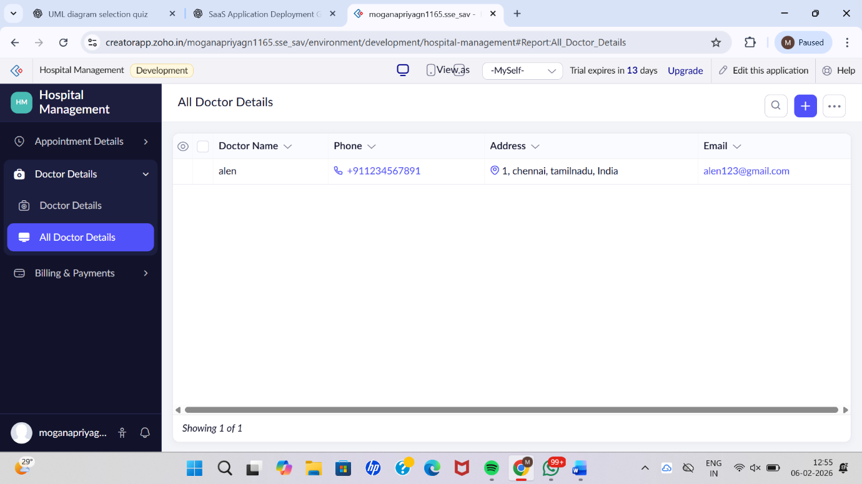

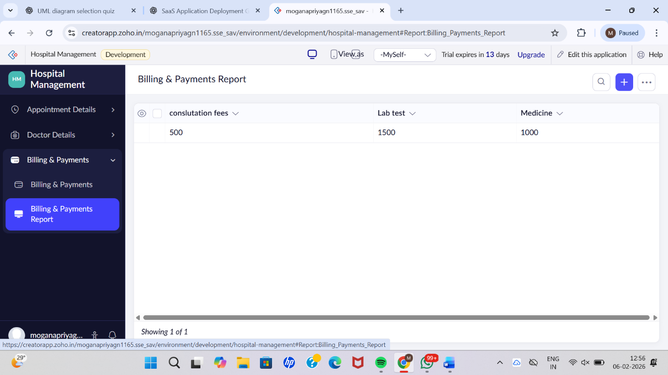

Result
Thus, a simple cloud-based Hospital Management System was successfully created and deployed using Zoho Creator. The application was provided as Software as a Service (SaaS), allowing users to access hospital services online without installing any software locally.

